Constructing Parabol

Definition
# Source: AI Source: Provided by: [Data Path: Persons Table -> ID Column: 1, Name_En Column: Motasem Essam] -> From: [ChatGPT] on [7/25/2026]
A parabola is a conic section consisting of all points that are equidistant from a fixed point and a fixed line.
The fixed point is called the focus, and the fixed line is called the directrix.
For any point $P$on the parabola:
$$\boxed{PF=d\left(P , l\right)}$$
where:
- $F$is the focus;
- $l$is the directrix;
- $d\left(P , l\right)$is the perpendicular distance from $P$to the directrix.
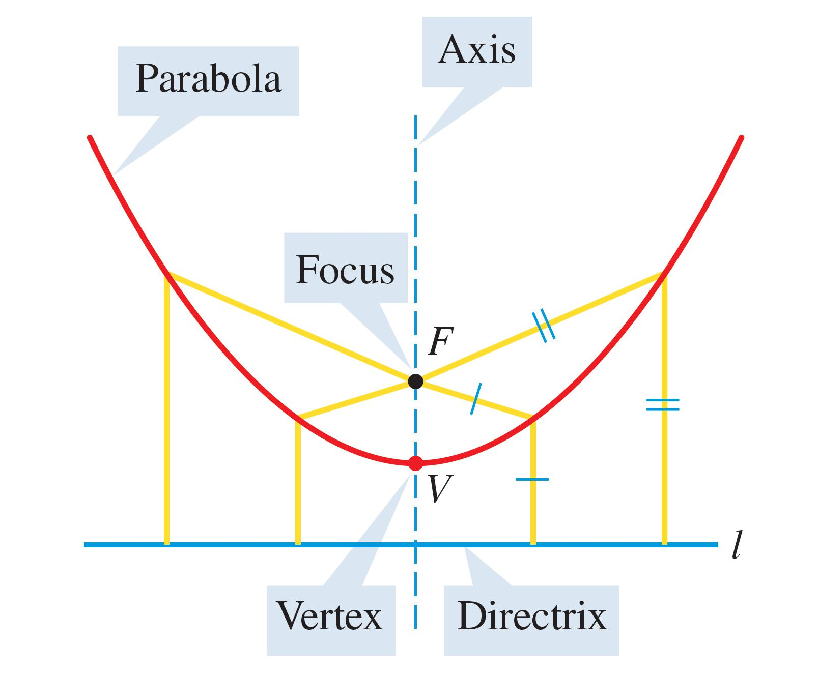
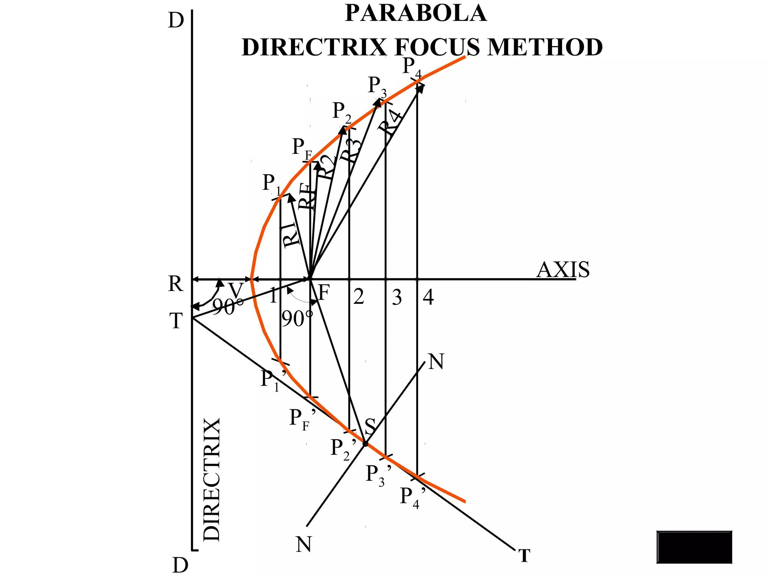
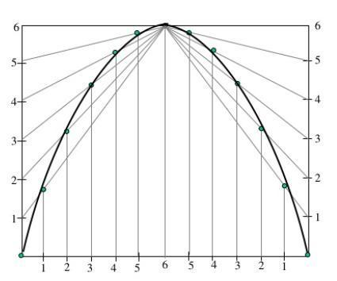
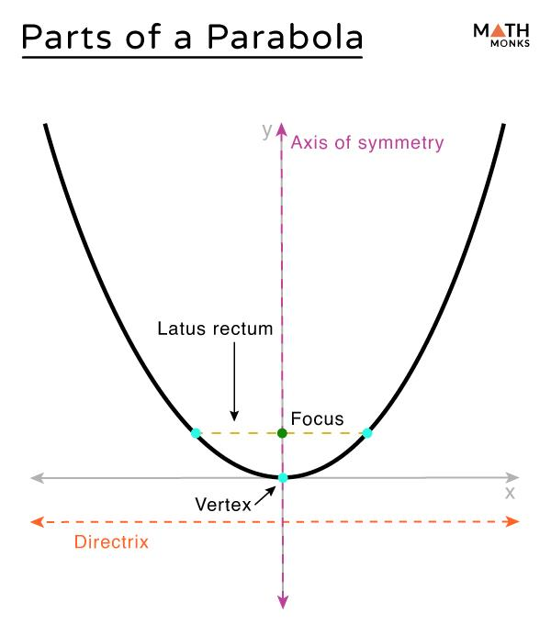

Fundamental Elements of a Parabola
# Source: AI Source: Provided by: [Data Path: Persons Table -> ID Column: 1, Name_En Column: Motasem Essam] -> From: [ChatGPT] on [7/25/2026]
Focus
The fixed point inside the parabola is the focus:
$$\boxed{F}$$
Directrix
The fixed line is the directrix:
$$\boxed{l}$$
Vertex
The vertex $V$is the point where the parabola reaches its minimum or maximum distance along its axis of symmetry.
Axis of Symmetry
The line passing through the focus and vertex and perpendicular to the directrix is the axis of symmetry.
Focal Length
The distance from the vertex to the focus is commonly denoted:
$$\boxed{p}$$
The distance from the vertex to the directrix is also:
$$\boxed{p}$$
Therefore:
$$\boxed{VF=p}$$

Fundamental Construction Principle
# Source: AI Source: Provided by: [Data Path: Persons Table -> ID Column: 1, Name_En Column: Motasem Essam] -> From: [ChatGPT] on [7/25/2026]
The defining property of a parabola is:
$$\boxed{PF=d\left(P , l\right)}$$
Therefore, to construct a parabola:
- Establish the focus.
- Establish the directrix.
- Construct points whose distance from the focus equals their perpendicular distance from the directrix.
- Connect the resulting points with a smooth curve.

Constructing a Parabola From a Focus and Directrix
# Source: AI Source: Provided by: [Data Path: Persons Table -> ID Column: 1, Name_En Column: Motasem Essam] -> From: [ChatGPT] on [7/25/2026]
This is the fundamental geometric construction.
Given
- Focus $F$.
- Directrix $l$.
Steps
- Draw the directrix $l$.
- Construct the perpendicular from $F$to $l$.
- Let the perpendicular meet $l$at $D$.
- Find the midpoint of $FD$.
- This midpoint is the vertex $V$.
Thus:
$$\boxed{VF=VD}$$
where $VD$is perpendicular to the directrix.
- Choose several points $Q_{1},Q_{2},…$on the directrix.
- Through each $Q_{i}$, construct a line perpendicular to the directrix.
- With center $F$, draw an arc whose radius is $FQ_{i}$.
- The intersection of the arc with the perpendicular through $Q_{i}$gives a point $P_{i}$on the parabola.
- Repeat on both sides of the axis of symmetry.
- Draw a smooth curve through the constructed points.
For every point $P_{i}$:
$$\boxed{P_{i}F=P_{i}Q_{i}}$$
Therefore, the resulting curve is a parabola.

Constructing the Vertex
# Source: AI Source: Provided by: [Data Path: Persons Table -> ID Column: 1, Name_En Column: Motasem Essam] -> From: [ChatGPT] on [7/25/2026]
The vertex is particularly important because it determines the position of the parabola.
Let $D$be the foot of the perpendicular from the focus to the directrix.
Then:
$$FD$$
is perpendicular to the directrix.
The vertex is the midpoint of $FD$:
$$\boxed{VF=VD}$$
Therefore:
$$\boxed{VF=\frac{FD}{2}}$$

Constructing a Parabola From Vertex and Focus
# Source: AI Source: Provided by: [Data Path: Persons Table -> ID Column: 1, Name_En Column: Motasem Essam] -> From: [ChatGPT] on [7/25/2026]
If the vertex $V$and focus $F$are given:
- Draw line $VF$.
- Extend the line through $V$in the direction opposite $F$.
- The directrix is perpendicular to $VF$.
- Locate the directrix at the same distance from $V$as the focus:
$$\boxed{VD=VF}$$
- Construct the directrix.
- Use the focus-directrix construction to generate additional points.
- Connect the points smoothly.

Constructing a Parabola Using the Focus-and-Directrix Method
# Source: AI Source: Provided by: [Data Path: Persons Table -> ID Column: 1, Name_En Column: Motasem Essam] -> From: [ChatGPT] on [7/25/2026]
A practical point-by-point construction can be organized as follows.
Step 1: Establish the Axis
Construct the perpendicular from the focus to the directrix.
Step 2: Locate the Vertex
The midpoint between the focus and the directrix is the vertex.
Step 3: Choose Directrix Points
Choose points:
$$Q_{1},Q_{2},Q_{3},…$$
along the directrix.
Step 4: Construct Perpendiculars
Through each $Q_{i}$, construct a line perpendicular to the directrix.
Step 5: Transfer the Focus Distance
For each $Q_{i}$, use:
$$FQ_{i}$$
as the radius of an arc centered at $F$.
Step 6: Locate Parabola Points
The intersection between the arc and the corresponding perpendicular gives $P_{i}$.
Thus:
$$\boxed{FP_{i}=P_{i}Q_{i}}$$
Step 7: Reflect
Use the axis of symmetry to obtain corresponding points on the opposite side.
Step 8: Draw the Curve
Connect the points with a smooth curve.

Constructing a Parabola Using a Tangent Method
# Source: AI Source: Provided by: [Data Path: Persons Table -> ID Column: 1, Name_En Column: Motasem Essam] -> From: [ChatGPT] on [7/25/2026]
A parabola can also be constructed using its tangent properties.
For a point $P$on a parabola:
- the tangent at $P$makes equal angles with $PF$and the line through $P$perpendicular to the directrix.
This property can be used to construct tangent lines after points on the parabola have been determined.
The tangent method is particularly useful when the problem specifies tangent information.

Constructing a Parabola Using an Auxiliary Rectangle
# Source: AI Source: Provided by: [Data Path: Persons Table -> ID Column: 1, Name_En Column: Motasem Essam] -> From: [ChatGPT] on [7/25/2026]
A graphical approximation can be made using an auxiliary rectangle or coordinate framework.
Steps
- Construct the axis of symmetry.
- Mark the vertex.
- Establish the focal distance $p$.
- Construct reference lines perpendicular to the axis.
- Divide the reference distances into corresponding intervals.
- Construct points satisfying the parabolic relationship.
- Reflect the points across the axis.
- Draw the smooth curve.
This method is useful for technical drawing and graphical construction, although the focus-directrix method directly expresses the defining geometric property.

Standard Equation
# Source: AI Source: Provided by: [Data Path: Persons Table -> ID Column: 1, Name_En Column: Motasem Essam] -> From: [ChatGPT] on [7/25/2026]
For a parabola with vertex at the origin and axis along the $x$-axis:
$$\boxed{y^{2}=4px}$$
where $p$is the distance from the vertex to the focus.
The focus is:
$$\boxed{F=\left(p , 0\right)}$$
and the directrix is:
$$\boxed{x=-p}$$

Vertical Parabola
# Source: AI Source: Provided by: [Data Path: Persons Table -> ID Column: 1, Name_En Column: Motasem Essam] -> From: [ChatGPT] on [7/25/2026]
For a parabola opening upward:
$$\boxed{x^{2}=4py}$$
The focus is:
$$\boxed{F=\left(0 , p\right)}$$
and the directrix is:
$$\boxed{y=-p}$$

Parabola With a Translated Vertex
# Source: AI Source: Provided by: [Data Path: Persons Table -> ID Column: 1, Name_En Column: Motasem Essam] -> From: [ChatGPT] on [7/25/2026]
If the vertex is:
$$\left(h , k\right)$$
and the axis is horizontal:
$$\boxed{{\left(y-k\right)}^{2}=4p\left(x-h\right)}$$
If the axis is vertical:
$$\boxed{{\left(x-h\right)}^{2}=4p\left(y-k\right)}$$

Types / Construction Situations
# Source: AI Source: Provided by: [Data Path: Persons Table -> ID Column: 1, Name_En Column: Motasem Essam] -> From: [ChatGPT] on [7/25/2026]
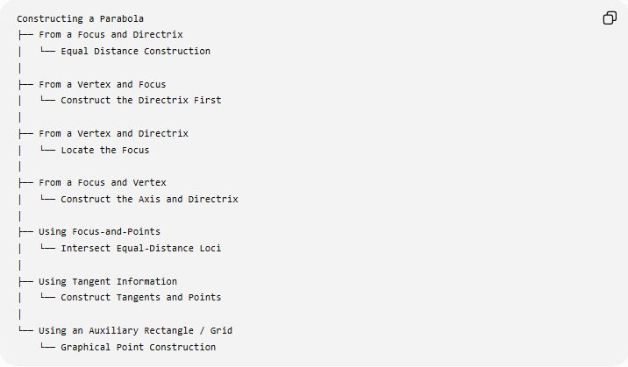
Constructing a Parabola
├── From a Focus and Directrix
│ └── Equal Distance Construction
│
├── From a Vertex and Focus
│ └── Construct the Directrix First
│
├── From a Vertex and Directrix
│ └── Locate the Focus
│
├── From a Focus and Vertex
│ └── Construct the Axis and Directrix
│
├── Using Focus-and-Points
│ └── Intersect Equal-Distance Loci
│
├── Using Tangent Information
│ └── Construct Tangents and Points
│
└── Using an Auxiliary Rectangle / Grid
└── Graphical Point Construction
Classification note: these are different construction situations or methods, rather than different mathematical types of parabolas.

Basic Constructions Used
# Source: AI Source: Provided by: [Data Path: Persons Table -> ID Column: 1, Name_En Column: Motasem Essam] -> From: [ChatGPT] on [7/25/2026]
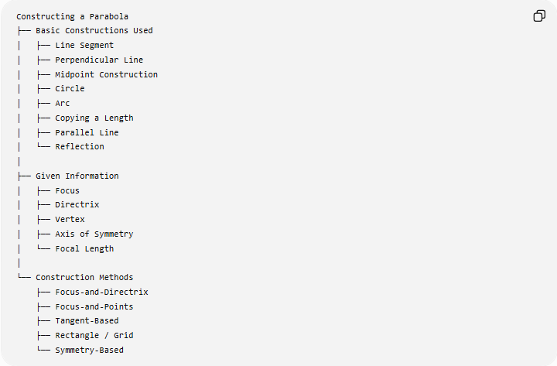
Constructing a Parabola
├── Basic Constructions Used
│ ├── Line Segment
│ ├── Perpendicular Line
│ ├── Midpoint Construction
│ ├── Circle
│ ├── Arc
│ ├── Copying a Length
│ ├── Parallel Line
│ └── Reflection
│
├── Given Information
│ ├── Focus
│ ├── Directrix
│ ├── Vertex
│ ├── Axis of Symmetry
│ └── Focal Length
│
└── Construction Methods
├── Focus-and-Directrix
├── Focus-and-Points
├── Tangent-Based
├── Rectangle / Grid
└── Symmetry-Based

Fundamental Properties
# Source: AI Source: Provided by: [Data Path: Persons Table -> ID Column: 1, Name_En Column: Motasem Essam] -> From: [ChatGPT] on [7/25/2026]
Focus-Directrix Relationship
$$\boxed{PF=d\left(P , l\right)}$$
Eccentricity
The eccentricity of a parabola is:
$$\boxed{e=1}$$
This is one of its defining characteristics as a conic.
Axis of Symmetry
A parabola has exactly one reflection axis:
$$\boxed{\text{Axis of Symmetry}}$$
Rotational Symmetry
A non-degenerate parabola does not have rotational symmetry about its vertex.

Focal Length
# Source: AI Source: Provided by: [Data Path: Persons Table -> ID Column: 1, Name_En Column: Motasem Essam] -> From: [ChatGPT] on [7/25/2026]
The focal length is:
$$\boxed{p=VF}$$
The focus and directrix are positioned symmetrically with respect to the vertex:
$$\boxed{VF=VD=p}$$
The distance from the focus to the directrix is therefore:
$$\boxed{FD=2p}$$

Latus Rectum
# Source: AI Source: Provided by: [Data Path: Persons Table -> ID Column: 1, Name_En Column: Motasem Essam] -> From: [ChatGPT] on [7/25/2026]
The latus rectum is the chord passing through the focus and perpendicular to the axis of symmetry.
Its length is:
$$\boxed{4p}$$
For:
$$y^{2}=4px$$
the endpoints of the latus rectum are:
$$\boxed{\left(p , 2p\right)}$$
and:
$$\boxed{\left(p , -2p\right)}$$

Parabola vs Ellipse
# Source: AI Source: Provided by: [Data Path: Persons Table -> ID Column: 1, Name_En Column: Motasem Essam] -> From: [ChatGPT] on [7/25/2026]
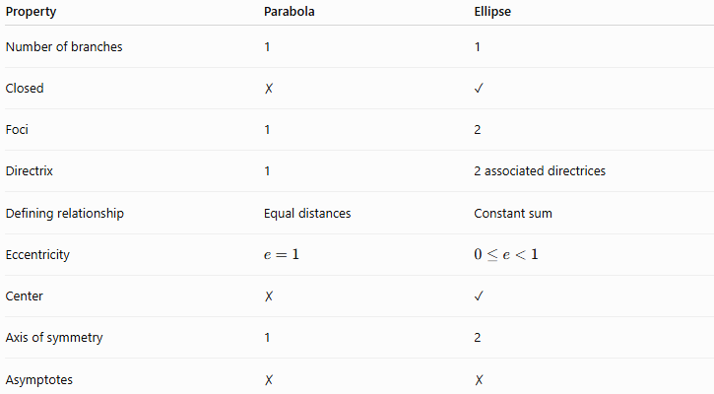
Property | Parabola | Ellipse
Number of branches | 1 | 1
Closed | ✗ | ✓
Foci | 1 | 2
Directrix | 1 | 2 associated directrices
Defining relationship | Equal distances | Constant sum
Eccentricity | $$e=1$$ | $$0≤e<1$$
Center | ✗ | ✓
Axis of symmetry | 1 | 2
Asymptotes | ✗ | ✗

Parabola vs Hyperbola
# Source: AI Source: Provided by: [Data Path: Persons Table -> ID Column: 1, Name_En Column: Motasem Essam] -> From: [ChatGPT] on [7/25/2026]
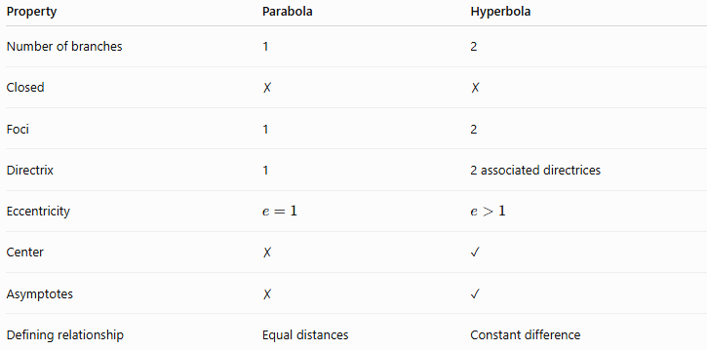
Property | Parabola | Hyperbola
Number of branches | 1 | 2
Closed | ✗ | ✗
Foci | 1 | 2
Directrix | 1 | 2 associated directrices
Eccentricity | $$e=1$$ | $$e>1$$
Center | ✗ | ✓
Asymptotes | ✗ | ✓
Defining relationship | Equal distances | Constant difference

The Three Principal Conic Sections
# Source: AI Source: Provided by: [Data Path: Persons Table -> ID Column: 1, Name_En Column: Motasem Essam] -> From: [ChatGPT] on [7/25/2026]
The conics can be classified by eccentricity:
$$\boxed{\begin{aligned}0≤e<1&→\text{Ellipse} \\ e=1&→\text{Parabola} \\ e>1&→\text{Hyperbola}\end{aligned}}$$
Their focal definitions are:
Ellipse
$$\boxed{PF_{1}+PF_{2}=\text{constant}}$$
Parabola
$$\boxed{PF=d\left(P , l\right)}$$
Hyperbola
$$\boxed{∣PF_{1}-PF_{2}∣=\text{constant}}$$

Classification in Geometric Construction
# Source: AI Source: Provided by: [Data Path: Persons Table -> ID Column: 1, Name_En Column: Motasem Essam] -> From: [ChatGPT] on [7/25/2026]
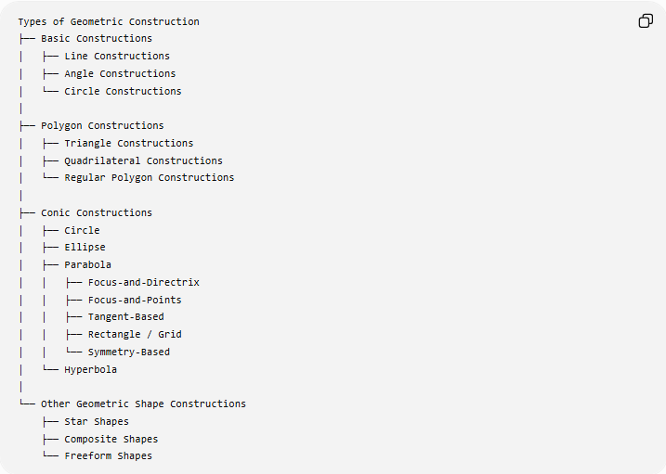
Types of Geometric Construction
├── Basic Constructions
│ ├── Line Constructions
│ ├── Angle Constructions
│ └── Circle Constructions
│
├── Polygon Constructions
│ ├── Triangle Constructions
│ ├── Quadrilateral Constructions
│ └── Regular Polygon Constructions
│
├── Conic Constructions
│ ├── Circle
│ ├── Ellipse
│ ├── Parabola
│ │ ├── Focus-and-Directrix
│ │ ├── Focus-and-Points
│ │ ├── Tangent-Based
│ │ ├── Rectangle / Grid
│ │ └── Symmetry-Based
│ └── Hyperbola
│
└── Other Geometric Shape Constructions
├── Star Shapes
├── Composite Shapes
└── Freeform Shapes

Key Points
# Source: AI Source: Provided by: [Data Path: Persons Table -> ID Column: 1, Name_En Column: Motasem Essam] -> From: [ChatGPT] on [7/25/2026]
- A parabola is a conic defined by equal distances from a focus and a directrix.
- Its fundamental property is:
$$\boxed{PF=d\left(P , l\right)}$$
- It has:
  - one focus;
  - one directrix;
  - one vertex;
  - one axis of symmetry.
- Its eccentricity is:
$$\boxed{e=1}$$
- For a standard horizontal parabola:
$$\boxed{y^{2}=4px}$$
- Its focus is:
$$\boxed{\left(p , 0\right)}$$
- Its directrix is:
$$\boxed{x=-p}$$
- The distance from the vertex to the focus equals the distance from the vertex to the directrix:
$$\boxed{VF=VD=p}$$
- The focus-directrix method provides a direct geometric construction.
- A parabola can also be constructed using points, tangent information, an auxiliary grid, and symmetry.

Conclusion
# Source: AI Source: Provided by: [Data Path: Persons Table -> ID Column: 1, Name_En Column: Motasem Essam] -> From: [ChatGPT] on [7/25/2026]
A parabola is a single open conic curve whose every point is equally distant from a fixed focus and a fixed directrix. Its fundamental construction therefore consists of generating points satisfying
$$\boxed{PF=d\left(P , l\right)}$$
The focus-and-directrix method provides the most direct geometric construction, while vertex-based, tangent-based, grid-based, and symmetry-based methods provide alternative construction situations. The parabola is distinguished from the ellipse and hyperbola by its eccentricity:
$$\boxed{e=1}$$
and by having one focus, one directrix, one branch, and one axis of symmetry.

